Hierarchical Bayesian Modeling of the Iowa Gambling Task using Prospect Valence Learning (PVL) Delta. It has the following parameters: A (learning rate), alpha (outcome sensitivity), cons (response consistency), lambda (loss aversion).

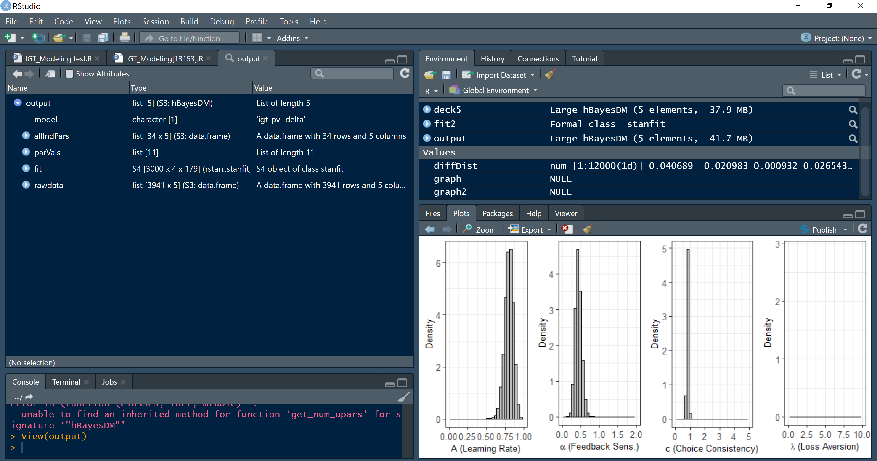

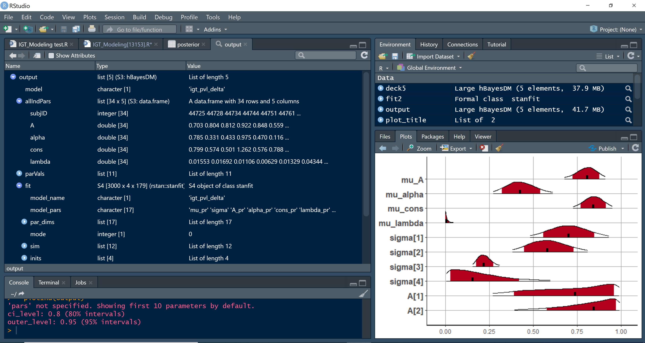

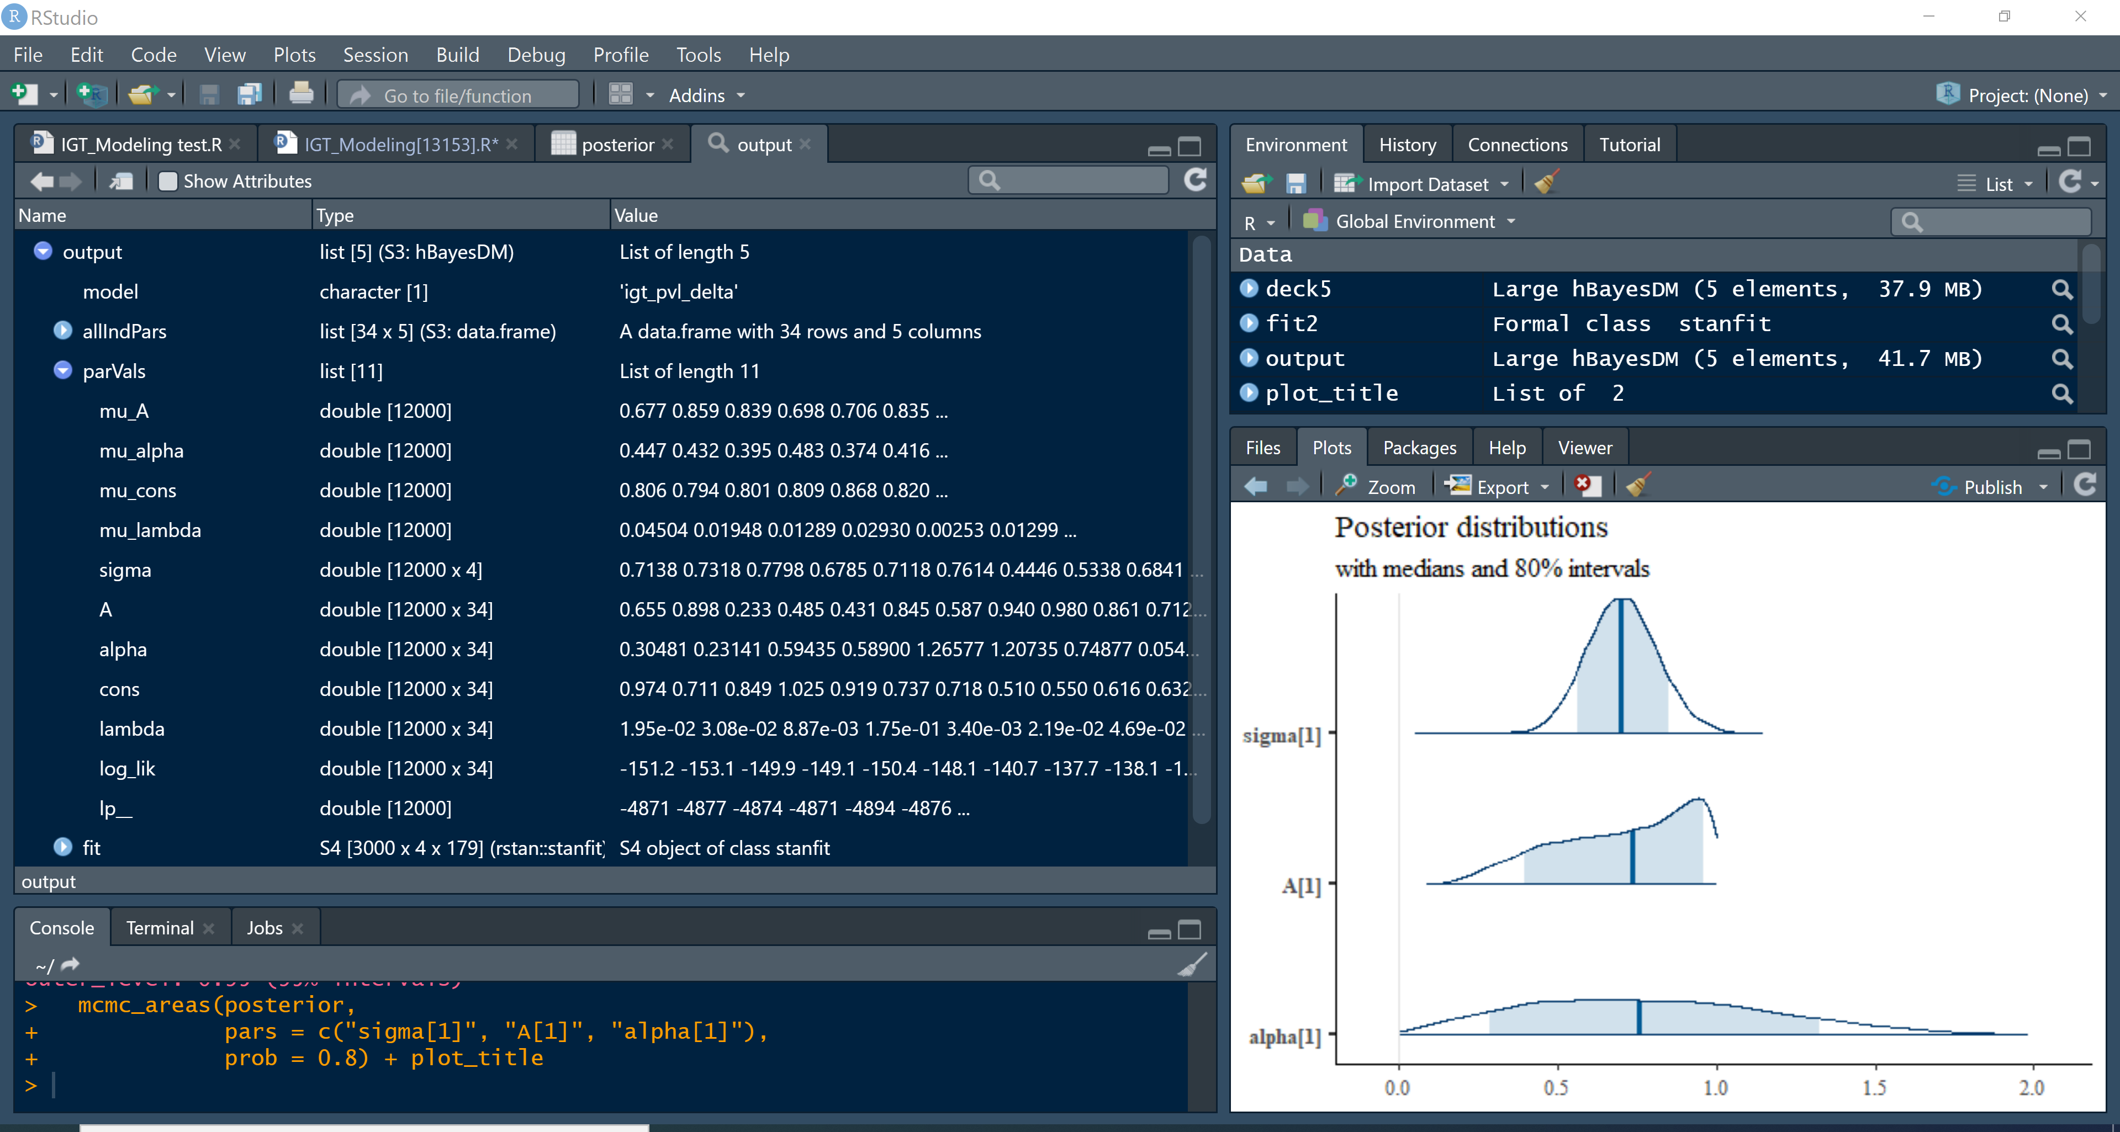

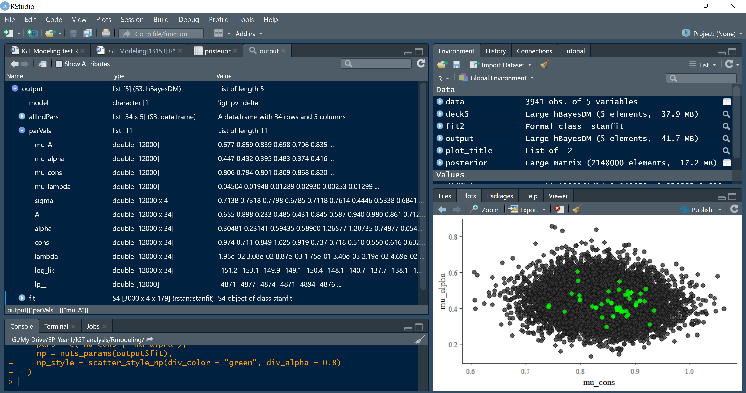

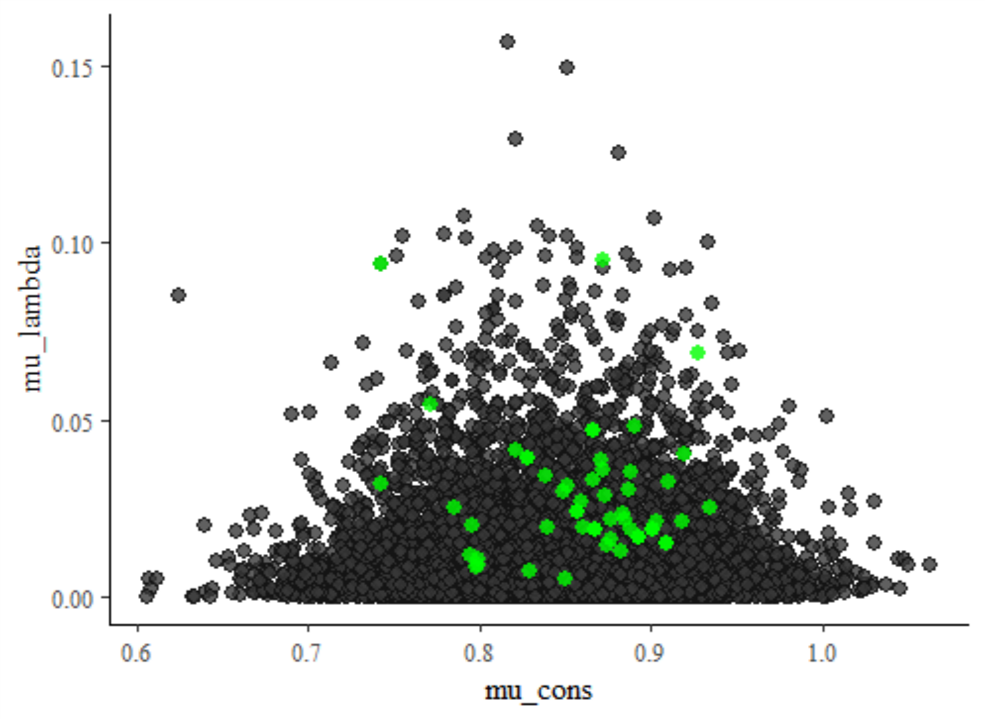

mu_cons =response consistency

mu_lambda=loss aversion

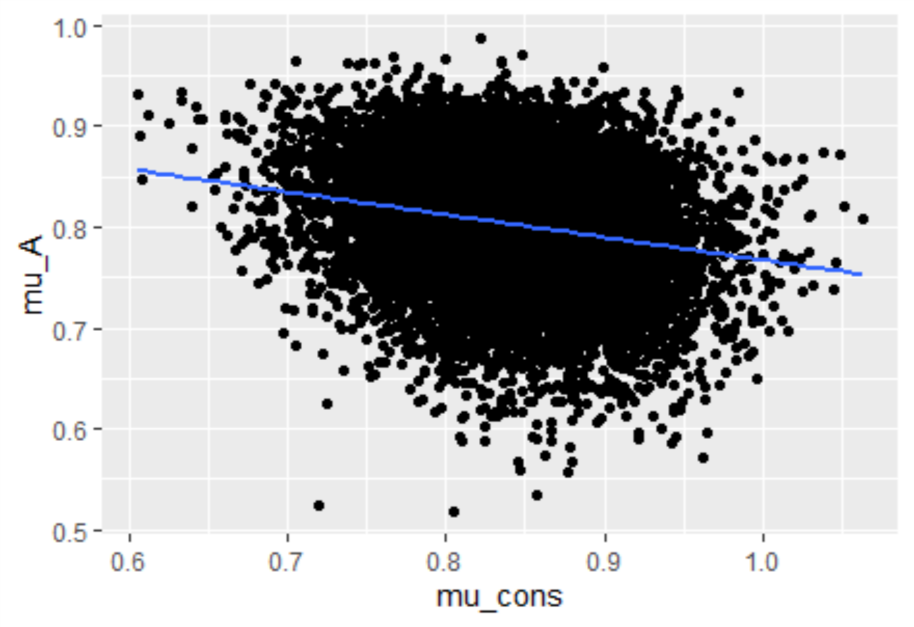

mu_cons=response consistency

mu_A=learning rate

